Park LaBrea News/Beverly Press

‘10-4 Day’ Honors CHP’s 80th Anniversary

October 8, 2009

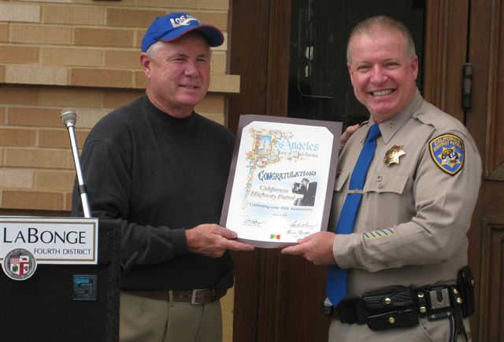
Councilman Tom LaBonge presenting a proclamation to CHP Assistant Chief Craig Klein

Dozens of vintage police cars were included in a parade down Hollywood Boulevard last Sunday in recognition of “10-4 Day”, which honors traffic safety officiers. The event is held annually by Los Angeles City Councilman Tom LaBonge, 4th District and culminates in front of the Kodak Theatre at the Walk of Fame (Movie) star of Broderick Crawford. (He also has a TV Star across the street).

Crawford starred in the famous 1950’s show “Highway Patrol”. His son Kelly also participated along with Art Gilmore, now 97 who narrated all 156 episodes. Larry Wilcox, Robert Pine and other stars from “CHiPs” were on hand as was K-EARTH’s Shotgun Tom Kelly who served as MC. Many CHP officers took part in the event this year which also marked the CHP’s 80th Anniversary.

